**IMAGE RECOGNITION**

**Phase 1:**

**Abstract:**

Image recognition is the process of identifying an object or a feature in an image or video. It is used in many applications like defect detection, medical imaging, and security surveillance.

**Problem Definition:**

The project involves creating an image recognition system using IBM Cloud Visual Recognition. The goal is to develop a platform where users can upload images and the system accurately classifies and describes the image contents .This will enable users to craft engaging visual stories with the help of Al-generated captions enhancing their connection with the audience through captivating visuals and compelling narratives.

**Objectives:**

1.In order to successfully apply the cloud computing to the administrative management of spatial structures and realize the systematization, digitization, and intelligence of administrative management, this article draws on research experience in related fields and considers the data characteristics and computing tasks of administrative management.

2. The traditional image recognition system research and practical application investigation, in order to meet the user’s requirements for the computing efficiency and recognition accuracy of the image recognition system, an image recognition system in the cloud computing environment is proposed.

3.It proposes a fuzzy evaluation algorithm of health grade hierarchy analysis optimized for the index system and scoring system and a calculation method that uses time series to identify regular outliers.

4.The optical image pixel-level fusion method and the infrared and visible image fusion method based on complementary information are proposed, and the image fusion software is developed.

5. In order to enable the application layer to use cluster resources to efficiently and intelligently process massive monitoring data containing redundancy, heterogeneity, anomalies, and many other defects, according to the calculation process of each specific task of data preprocessing and postprocessing in the application layer, demonstrations are made one by one.

6. After analysis, it is concluded that vertical storage of data blocks according to different sensor channels is the optimal strategy.

**Design Thinking:**

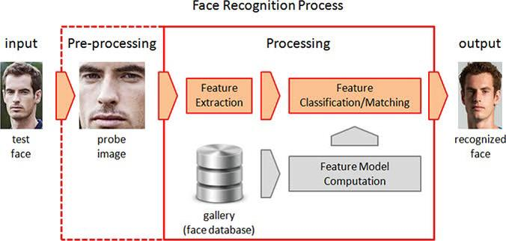

1.The new images are enrolled through the user interface or user application.

2. The user interface enrolls new faces and encodes the image, which is then sent to the cloud-based API that processes the image through the image recognition engine.

3.The image recognition engine runs a pre-defined image recognition algorithm.

4.The query image from the user interface is then compared by the image recognition engine against a gallery of images.

5. After a conclusive match is determined, the query image will be classified as belonging to a particular individual or not.

6.Then, the result will be sent back to the user interface.

**Conclusion:**

1.Cloud-based image recognition systems bring about various benefits coming from inherent characteristics.

2. They have the advantage of real-time processing.

3.On demand self-service allows customers to quickly procure and access the services they want.

4.Moreover, cloud computing allows the system to become broadly accessible in the sense that cloud services provide the capability for quick and reliable integration with other applications.

5.In addition, cloud services facilitate high scalability in order to ensure that the system can be adapted to a wide user base.